- Usecase
- Player
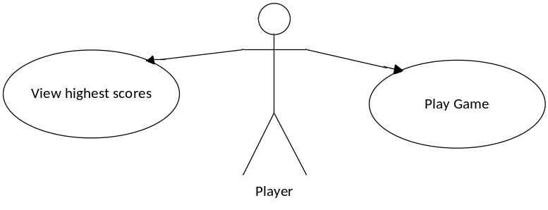
- Admin
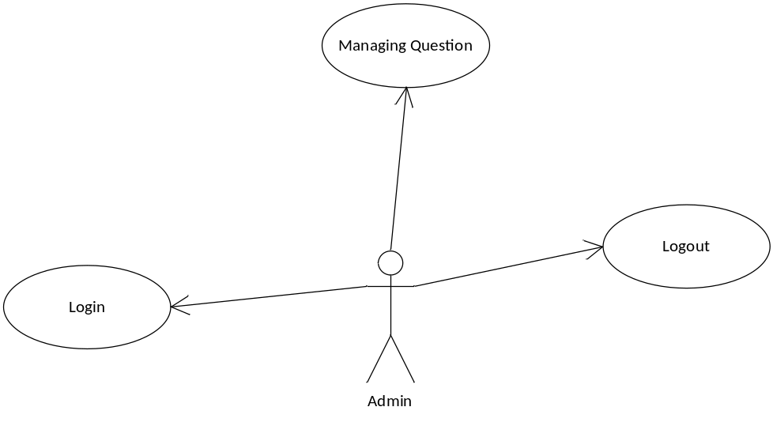
- Specification details
- Player
- Play
Step 1. Display player form.
Step 2. Enter a player name.
Step 3. Read question and Enter letters in the box.
Step 4. Press next button
Step 5. Check for proper end or not?
If true?
Bring to a higher level
Return to step 3
If false?
Display score, player name and question id.

